_______________________________________________________________________________________________________

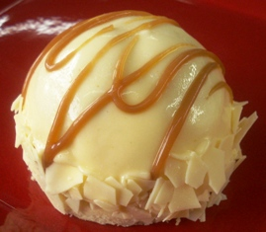 “Gluten-Free” Banana’s Foster  
 Peterson Item #00286

Description: A “Gluten Free” Shortbread crust is topped with banana’s foster actually made like they are table side with fresh banana’s, brown sugar, cinnamon, Meyers dark rum, butter and a hint of lemon to balance the sauce. A layer of our white chocolate vanilla silk mousse (tastes JUST like ice cream but doesn’t melt like ice cream) is topped on the bananas then glazed with our white chocolate banana silk then decorated with caramel

Ingredients: White chocolate (sugar, cocoa butter, milk, soya lecithin, pure vanilla), pasteurized egg (whole egg), butter (milk cream), fresh banana, cream (milk), vanilla bean, Bob’s Red Mill (1 to 1) flour brown sugar, Meyers Dark Rum, lemon puree, spices.

Fruchtpast from Peterson Co: The glaze is our white chocolate silk and the Fruchtpast (Banana pulp 50% glucose syrup inverted sugar syrup ethyl alcohol, thickener: modified starch, acidulant: citric acid, color: riboflavin).

Packaging: 12 CT CS…..Weight: 4.65 OZ  
Case Dims: 11 ½ x 16 x 3 ¼   
Shelf Life: 12 MO. Frozen @-10 or colder

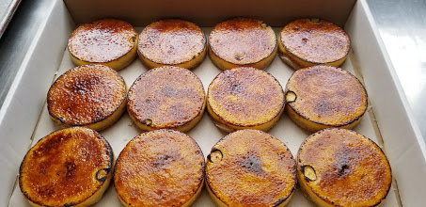 “Gluten-Free” Crème Brulee Cheesecake  
 Peterson Item #63062

Description: Our own Shortbread crust is baked and topped with our white chocolate crème brulee cheesecake batter then fired 3 times with sugar to caramelize the sugar on top of the dessert.

Ingredients: White Chocolate (sugar, cocoa butter, milk, soya lecithin, pure vanilla), cream cheese (pasteurized cultured milk and cream, salt, stabilizers (xanthan and /or carob bean and/or guar gums), Butter (milk cream), Pasteurized Egg (whole egg), Sour Cream (cultured grade A cream, non fat milk, enzyme Contains: Milk), Sugar, Bob’s Red Mill 1 to 1 flour.

Packaging: 12 CT CS…..Weight: 4 OZ. EACase   
Dims: 11 ¼ x 15 1/8 x 2 ¼  
Shelf Life: 12 MO. Frozen @-10 or colder

“Gluten-Free” Key Lime  
 Peterson Item #63064  
Description: Our gluten free Shortbread crust is topped with a layer of our white chocolate key lime silk then finished with a layer of our white chocolate key lime silk mousse and Mona Lisa curls. Did you know that our Key Lime is one of our BEST SELLERS and was in the Neiman Marcus catalogs for 33 years until they filed BK in 2022.

Ingredients: White Chocolate (sugar, cocoa butter, milk, soya lecithin, pure vanilla), Butter (milk cream), Cream (milk), Pasteurized Egg (whole egg), Bob’s Red Mill Flour (1 to 1), Key Lime Puree, White Chocolate Curls (sugar, cocoa butter soya lecithin (<1%), ground vanilla beans *may contain traces of whole milk and whey powders)

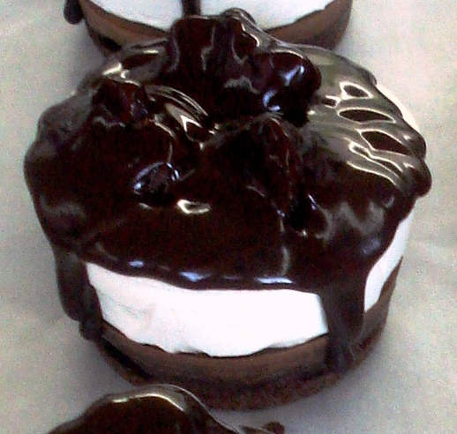Packaging: 12 CT CS…..Weight: 4.25 OZ EA  
Case Dims: 11 ½ x 16 x 3 ¼”  
Shelf Life: 12 MO. Frozen @-10 or colder

“Gluten-Free” Hot Fudge Sundae  
Peterson Item #00074  
Our # 1 Selling Dessert, Hands down!  
Description: Our Gluten free semi sweet flourless bottom with a thin layer of our original dark chocolate silk. Our white chocolate pure vanilla silk mousse it topped with flourless semi sweet brownie chunks and our dark chocolate ganache…..simply wonderful! This dessert is our 2nd best sellers and has been now for the past 4 years!

Ingredients: Butter(milk cream), Cream(milk), Pasteurized Egg(whole egg), chocolate liquor Semi Sweet (sugar, chocolate liquor, cocoa butter, dextrose) and soya lecithin) Processed on equipment previously used to process milk chocolate) white chocolate(sugar, cocoa butter, milk, soya lecithin, pure vanilla)

Packaging: 12 CT CS…..Weight: 4 ½ OZ EA  
Case Dims: 11 ½ x 16 x 3 ¼”  
Shelf Life: 12 MO. Frozen @-10 or colder

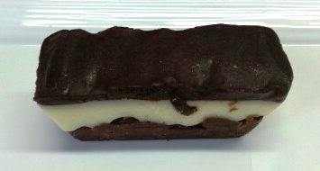“Gluten-Free” Nanaimo Bars Individuals  
 Peterson Item #14753

Description: A bottom layer of our signature dark chocolate silk/ganache, Bob’s Red Mill coconut flakes, dry roasted coarse chopped almonds (dry roasted here at the bakery), and almond shortbread pieces. A middle layer of our white chocolate cream vanilla silk topped with our own house made ganache. This is a single bar in the form of an Ingot but the gold has been excluded.

Ingredient: White Chocolate (sugar, cocoa butter, milk, soya lecithin, pure vanilla), Butter (milk cream), Pasteurized Egg (whole egg), Cream (milk), chocolate liquor (pure chocolate), Almonds, Semi Sweet Chocolate:(sugar, chocolate liquor, cocoa butter, dextrose), Almonds, Coconut Flakes.   
  
 Packaging: 24 CT CS…..Weight: 3.75 OZ. EA  
 Case Dims: 11 ½ x 16 x 3 ¼  
 Shelf Life: 12 MO. Frozen @-10 or colder  
  
“Gluten-Free” Mocha Pyramid  
 Peterson Item #00281  
Description: a base of cocoa nibs topped with a layer of our dark chocolate silk, a middle layer of our **milkchocolate silk (**2 parts white silk and 1 part dark silk) with cinnamon, orange, and espresso followed by a top layer of our dark chocolate silk. A topping of white chocolate silk frosting and a duo mocha bean tops this dessert.

Ingredients: White chocolate (sugar, cocoa butter, milk, soya lecithin, pure vanilla), pasteurized egg (whole egg), butter (milk cream), cream (milk), chocolate liquor, orange puree, espresso, spices, cocoa nibs.

Packaging: 12 CT CS…..Weight: 3.75 OZ. EA  
Case Dims: 11 ½ x 16 x 3 ¼  
Shelf Life: 12 MO. Frozen @-10 or colder

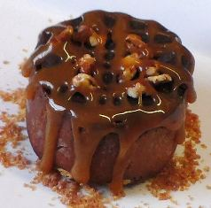 “Gluten-Free” Turtle Silk  
 Peterson Item # 63063

Description: A roasted pecan and caramel bottom is topped with a layer of our own dark original silk, a layer of ganache, roasted pecans and more Yukon Jackson artisanal caramel. The caramel is made by Yukon Jackson here at our bakery. It might be just the best caramel we have ever tasted.

Ingredients: Butter (milk cream), Cream (milk), Pasteurized Egg (whole egg), Chocolate (chocolate liquor), sugar, Semi Sweet (sugar, chocolate liquor, cocoa butter, dextrose) and soya lecithin) Processed on equipment previously used to process milk chocolate) Chocolate (chocolate liquor), Pecans, Caramel (cocoa butter, cream, sugar, inverted sugar)

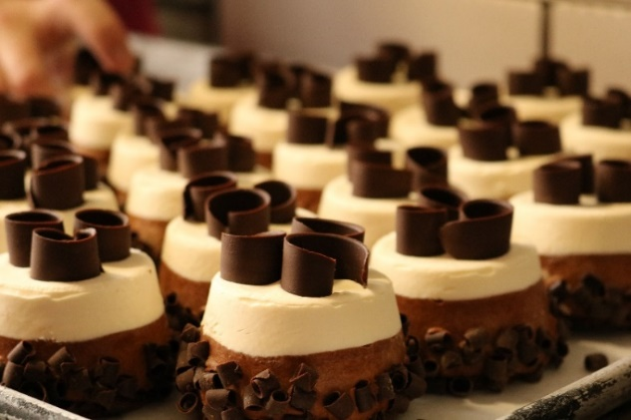Packaging: 12 CT CS…..Weight: 4.25 OZ EACase   
Dims: 11 ¼ x 15 1/8 x 2 ¼   
Shelf Life: 12 MO. Frozen @-10 or colder

“Gluten-Free” Black Forest   
Peterson Item #05905

Description: Our “gluten free” devils food cake is topped with a layer of our dark chocolate silk, Griottine Kirsch marinated cherries, and our white chocolate Kirsch silk mousse.

Ingredients: White Chocolate (sugar, cocoa butter, milk, soya lecithin, pure vanilla), Butter (milk cream), Pasteurized Egg (whole egg), Cream (milk), dark chocolate silk (chocolate liquor), Manini’s flour blend(organic millet, tapioca, teff, organic sorghum, organic amaranth, corn starch, organic cane sugar, gluten free xanthan gum, organic Atlantic sea salt, ascorbic acid), Griottine cherries (sugar, alcohol cherries, Kirsch), chocolate curls (cocoa mass, sugar, cocoa butter, soya lecithin (<1%>, ground vanilla beans).

* Packaging: 12 CT CS…..Weight: 4 OZ EA  
  Case Dims: 11 ½ x 16 x 3 ¼  
  Shelf Life: 12 MO. Frozen @-10 or colder  
  A chocolate covered dessert on a plate

  Description automatically generated  
    
  A box of chocolate donuts

  Description automatically generated “Gluten-Free” Caramel Mt. Madness  
   Peterson Item #00282

Description: Sea salted peanuts are the base for this dessert topped with our dark AK Silk. The top layer of our Adams chunky white chocolate peanut butter mousse is glazed with our AK dark silk and house made ganache.

Ingredients: Pasteurized egg (whole egg), Butter (milk cream), Cream (milk),Chocolate (chocolate liquor), Semi Sweet (sugar, chocolate liquor, cocoa butter, dextrose) and soya lecithin) Processed on equipment previously used to process milk chocolate), Peanut butter, Sea Salt peanuts, Caramel (sugar, cream cocoa butter, inverted sugar)

Packaging: 12 CT CS…..Weight: 4.25 OZ EA  
Case Dims: 11 ¼ x 15 1/8 x 2 ¼  
Shelf Life: 6 MO. Frozen @-10 or colder

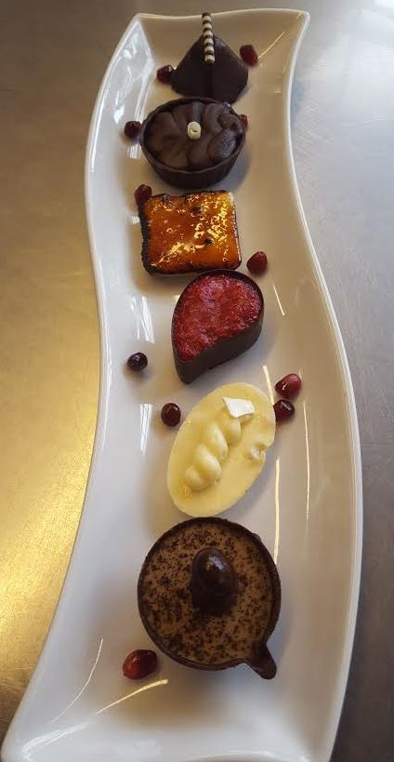  
Exclusively” Available “ONLY” from the Peterson Co.  
“Gluten-Free” Mini Bites Item #01110  
This is our version of a Petit Four…We like to be different

Descriptions: Square…Gluten Free Shortbread crust, white chocolate crème brulee cheesecake   
 Oval: Coconut crust, lemon white chocolate cheesecake and passion fruit   
 Coffee Cup: bottom of cup is dark chocolate espresso and on top our white chocolate espresso cream, coffee sprinkle and a chocolate covered mocha bean  
 Pyramid: Quad chocolate Silk/cheesecake/ganache with a white chocolate top  
 Triple Chocolate Cup: Chocolate cup, dark silk, ganache  
 Raspberry Cup: Our dark chocolate raspberry silk topped with glazed raspberries

**Packaging & Weight Approx. 1- 2 OZ each** 144 per case  
 24 of each flavor  
 6 layers, 6 flavors & 6 different shapes   
 **Shelf Life: 12 MO. Frozen @-10 or colder**

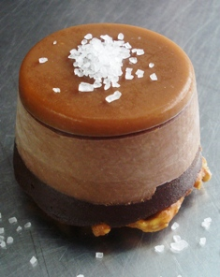 Salted Chocolate Caramel “NOT” Gluten-Free   
 Peterson Item #00280  
Description: A base of salted pretzels and caramel topped with our house made ganache, a layer of our dark chocolate silk has been finished with our Yukon Jackson Artisan caramel manufactured here at the bakery. We have finished this wonderful dessert with Woodinville’s Salt Works own Sea Salt. Although this dessert is a dessert that contains gluten in the pretzels, we have a dedicated “Gluten Room” that we do the only 2 desserts that contain gluten.

Ingredients: Pasteurized egg (whole egg), butter (milk cream), cream (milk), Chocolate (chocolate liquor), semi-sweet chocolate (sugar, chocolate liquor, cocoa butter, dextrose) and soya lecithin), pretzels, (white (wheat) flour, malt, sea salt, yeast, and water), caramel (sugar, cream, cocoa butter, inverted sugar)  
 Packaging: 12 CT CS…..Weight: 4.25 OZ EA  
 Case Dims: 11 ¼ x 15 1/8 x 2 ¼  
 Shelf Life: 6 MO. Frozen @-10 or colder  
   
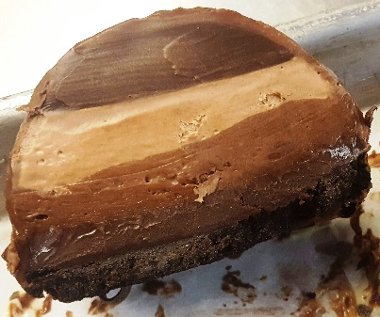

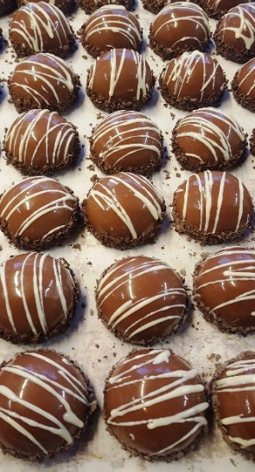Chocolate Silk Mousse…NOT…Gluten Free

Peterson Item #  
Description: Chocolate Cookie crust, chocolate silk mousse surrounded by our own chocolate ganache then encased in our chocolate silk. This dessert is then finished with more chocolate ganache and white chocolate silk swirled throughout the top.

Ingredients: Cream (milk), butter (milk cream), Pasteurized Egg (whole egg), Chocolate (chocolate liquor), sugar, crust (enriched wheat flour(flour, niacin, reduced iron, thiamine monoitrate, riboflavin, folic acid), sugar, cocoa powder, canola oil, water, cooking molasses, wheat bran, leavening(baking soda, ammonium bicarbonate), honey), ganache (semi sweet,(sugar, chocolate liquor, cocoa butter, dextrose) and soya lecithin), cream (milk), dark blossom curls (sugar, chocolate liquor, cocoa butter, butter oil (milk), emulsifier (soy lecithin, natural vanilla, chocolate noir (cocao: 50% minimum) Contains Wheat. Processed in a plant that contains peanuts, tree nuts, soy, egg, and milk ingredients.

Packaging: 12 CT CS…..Weight: 4.25 OZ EA  
Case Dims: 11 ½ x 16 x 3 ¼  
Shelf Life: 6 MO. Frozen @-10 or colder

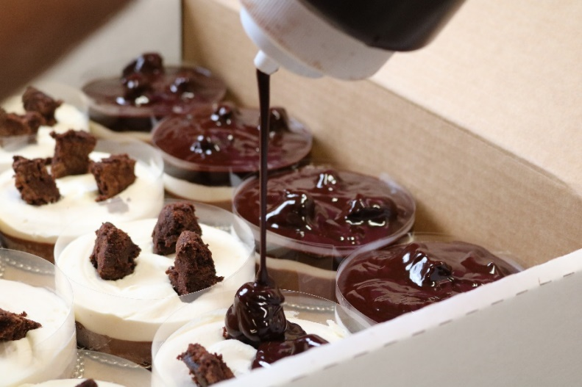

“Gluten-Free” Hot Fudge Sundae Silk Large   
 Peterson Item #63060

Description: Our flourless brownie base topped with a thin layer of dark chocolate silk, our white chocolate vanilla silk mousse, more flourless brownie chunks and ganache. This dessert is designed to share. We have served 4 with this dessert because they are so decadent….how many truffles can you eat?

Ingredients: Butter(milk cream), Cream(milk), Pasteurized Egg(whole egg), chocolate liquor Semi Sweet (sugar, chocolate liquor, cocoa butter, dextrose) and soya lecithin) Processed on equipment previously used to process milk chocolate) white chocolate(sugar, cocoa butter, milk, soya lecithin, pure vanilla)

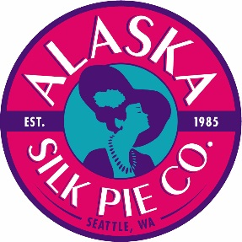Packaging: 12 CT CS…..Weight: 8 OZ. EA  
Case Dims: 11 ½ x 16 x 3 ¼  
Shelf Life: 12 MO. Frozen @-10 or colder



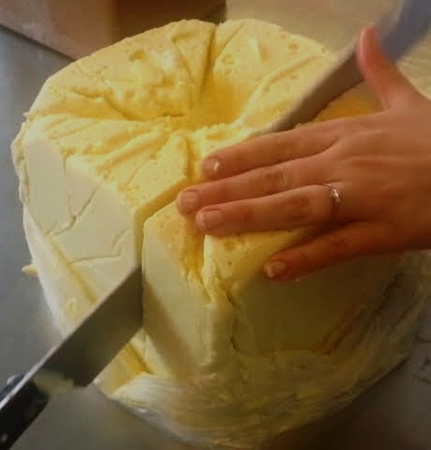 WHAT IS SEATTLE SILK?  
 ** A “Gluten Free” Unique Chocolate-based Ready-to-use Foundation  
 ** Easily used for Creating Quick and Easy Desserts  
 ** You are Only Limited by Your Own Imagination  
 ** Use as a building block to produce delicious fillings  
 mousses…..frosting…..glazes…..sauces and more   
 **‘Clean’ All-Natural pastry base is adaptable and simple to use  
  
Seattle Silk: ChocoBlanka (White Chocolate silk)  
Peterson Item #25087….. SPECIAL ORDER

Seattle Silk: ChocoScura (Dark Chocolate Silk  
 Peterson Item #25088…..SPECIAL ORDER

Packaging: 1/10 LB Block….Case Dims: 8x8x5  
Shelf Life: 12 MO. Frozen @-10 or colder  
Can be re-frozen without compromising the quality of the product